Chakli Machine

Hardware

Stepper Motor

Stepper Driver

TB6600

Features
- Basic stepper driver

TMC2209

Features
- Silent mode
- Sensor-less homing

Emergency Stop

Display

Search alternative to VFD

Start button

Firmware

G-Codes
G-Codes | Description
G1001 | Feeder Control
G1002 & G1003 | Spiral / Cricle (CW & CCW)
G1004 & G1005 | Spiral / Cricle (CW & CCW) with table planning
G1006 | Line

G1001 - Feeder control

Parameters
- D - Direction

Command Requirements
- D - Direction control
- 0 value to stop
- Positive value for forward
- Negative value for reverse
- Stop first when direction set

G1002 & G1003 - Spiral / Circle (Clockwise & counter-clockwise)

Parameters
- X - horizontal center location in mm (int)
- Y - vertical center location in mm (int)
- R - inner start radius of circle in mm (int)
- P - number of turns in step of 0.25 (float)
- S - spacing between two parallel arcs in mm (int)
- F - feed-rate at which table is moved (int)
- D - start delay in milliseconds (int)
- C - end delay in milliseconds (int)
- H - hole diameter in mm

Command requirements
  - Draw spiral staring from X, Y as center location
  - Go to X, Y only if all spiral min-max (top, bottom, left & right) inside table size, or send error as reply.
  - R shall be from 1mm to 50mm, default to 5
  - P shall be from 1.0 to 15.0 with step size 0.25 (90degree), default to 4.0
    - Draw arcs in 90 degrees of incremental
  - S shall be from 1mm to 30mm, default to 9
  - F shall be from 10mm/sec to 100mm/sec (600 - 6000mm/min), default to 30 (3000)
    - Mm/min = 60 * mm/sec
    - Can we set higher feed rate at end to cut?
  - D shall be from 0.0sec to 2.0sec (0 - 2000ms), default to 0
  - C shall be from 0.0sec to 1.0sec (0 - 1000ms), default to 700
  - H shall be from 1mm to 60mm, default to 5

Drawing requirements
- Check all params are received, if no then send error
- Check all params are in limit, if no then send error
- Calculate & check if spiral fits on table min-max, if no then send error
  - Formula
    - Step Size = S + H
    - Spiral Size = R + (round(P) * Step Size)
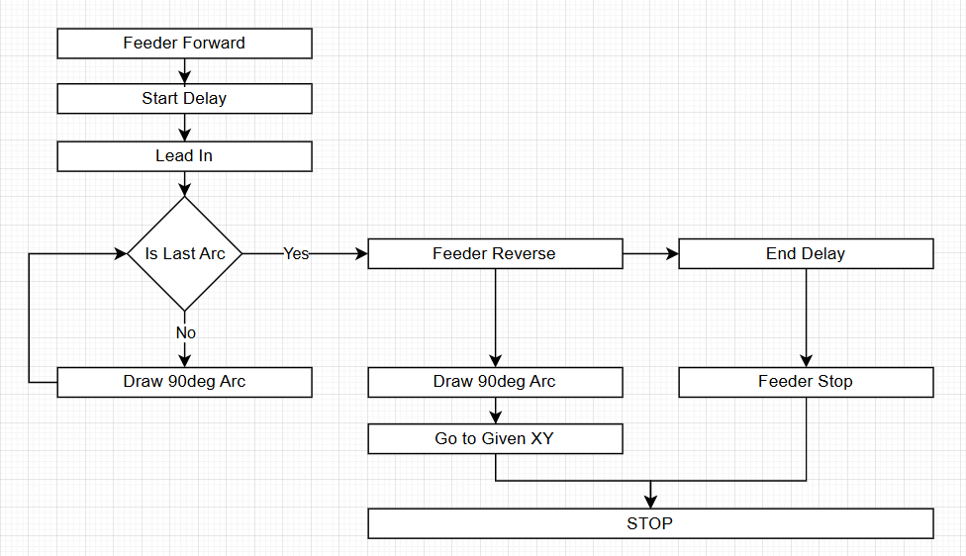

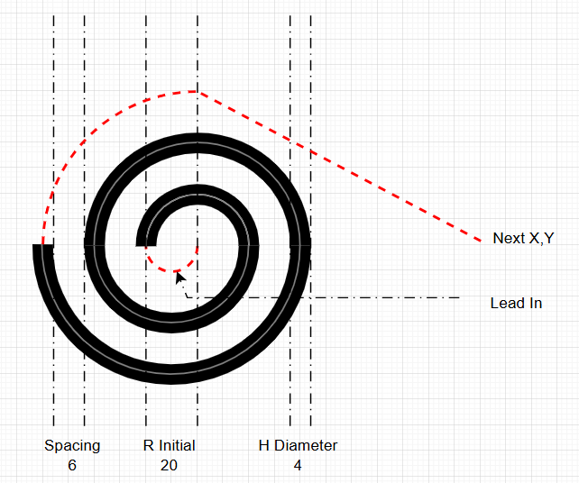

- For even half arcs (upper) center is at X, Y
- For odd half arcs (lower) center is at X-(R*0.5), Y

G1006- Line

G1007- Stepper Configuration
Pitch

G1008- Table Configuration
Size

TMC 2209 Sensor-less homing (StallGuard2)

Start Button

Mobile / PC Software

Wizard for setup
Optimize app flow for better usability

Issues

Hardware

Firmware
- Feeder G-code not available
- Spiral G-Code does not match requirements

Mobile or PC App
- Update mobile app to support only above issues

